Networking Devices

- Hub
- Bridge
- Switch
- Router
- Gateway

- Hub :-
- LAN device
- Works on Layer- 1(Physical Layer)
- Always broadcast
- Electrical or binary signals can be sent by hub
- Doesn’t store MAC addresses
- Half duplex (only one can send packet at once)
- Single collision domain
- Types :
  - Active hub :- acts as a repeater(amplify analog signals or regenerate binary signals), and It needs electricity
  - Passive hub :- Only propagates the signal
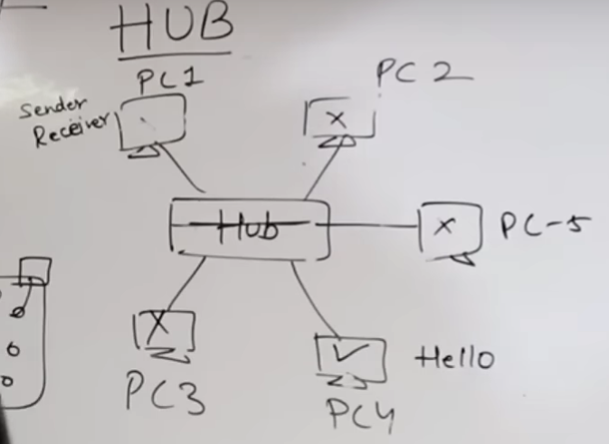

Sender
Hub

Receiver

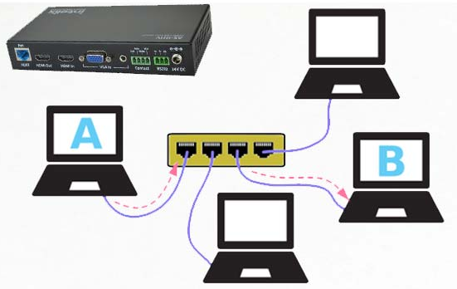

- Bridge :-
- LAN device
- Layer-2 device (Data link layer)
- Stores MAC addresses in a table.
- Used to connect multiple LAN segments or LAN segments.
- It divides the LAN into 2 parts.
- Bridge inspects the incoming traffic and decides whether to forward or reject it. It checks source and destination mac address.
- Working :-
- Bridge firstly broadcast to the both LAN segments and once the MAC of sender and receiver is known then it only broadcasts to the segment where receiver is present.
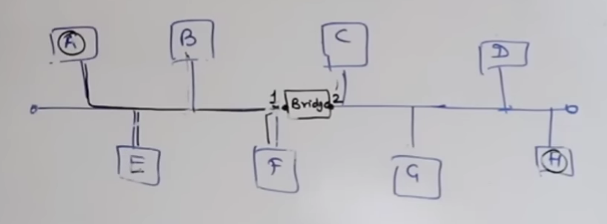

LAN -2
LAN -1

- Scenario -1 : A wants to send message to H.
- When A sends message, the bridge broadcasts msg to the both sides, and once H sends acknowledgement, it stores the MAC addresses of both A & H along with port numbers.
Port No. | MAC address
1 | A
2 | H

- Scenario – 2 : B wants to talk to G.
- When B sends message, bridge broadcasts msg to both the segments, once G acknowledges the msg, it stores the MAC of both to the table.
Port No. | MAC address
1 | A,B
2 | H,G

- Scenario – 3 : A wants to talk to E.
- When A sends msg to E, the bridge still broadcasts even though belonging to the port-1 as the MAC of E is unknown. Once E acknowledges the msg, its MAC address is stored in table.
Port No. | MAC address
1 | A,B,E
2 | H,G

- Scenario – 4 : A wants to talk E again.
- As mac of both are known, bridge will broadcast the message to the LAN segment 1 only.

- Switch (Multiport Bridge) :-
- Layer-2 device (Data-Link layer)
- Full duplex
- Maintains CAM(content accessible memory) table.
- First broadcast, then unicast and multicast.
- Every port of switch has separate collision domain.
- Switch has only one broadcast domain.
- 6/8/24/48 ports available.
- Uses ASICS (Application Specific ICs)
- Slower
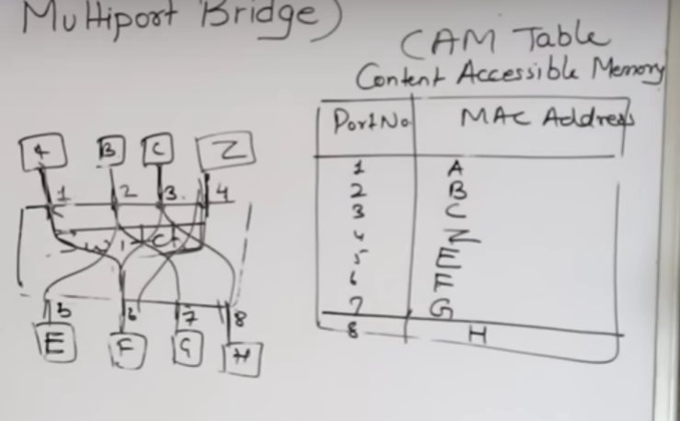

- Modes of Switches :
- Store & forward switch :
- The switch buffers and verifies each frame, before forwarding it.
- It’s a little bit slow.
- Cut through switch :-
- It only checks MAC address and then forwards the frame.
- There’s no error checking.

- Fragment free switch :-
- A methods that retains merits of both store& forward switch & cut through switch.
- It only checks first 64 bytes of frame.

- Adaptive switching :
- A method of automatically selecting between other modes of switching.

- Router :-
- Layer – 3 device
- WAN device
- Internetworking device
- Connects two or more networks.
- In router, Each port has its own broadcasting domain.
- Uses IP addresses to maintain Routing table.
- 2/4/8 ports.
- Faster compare to switches.
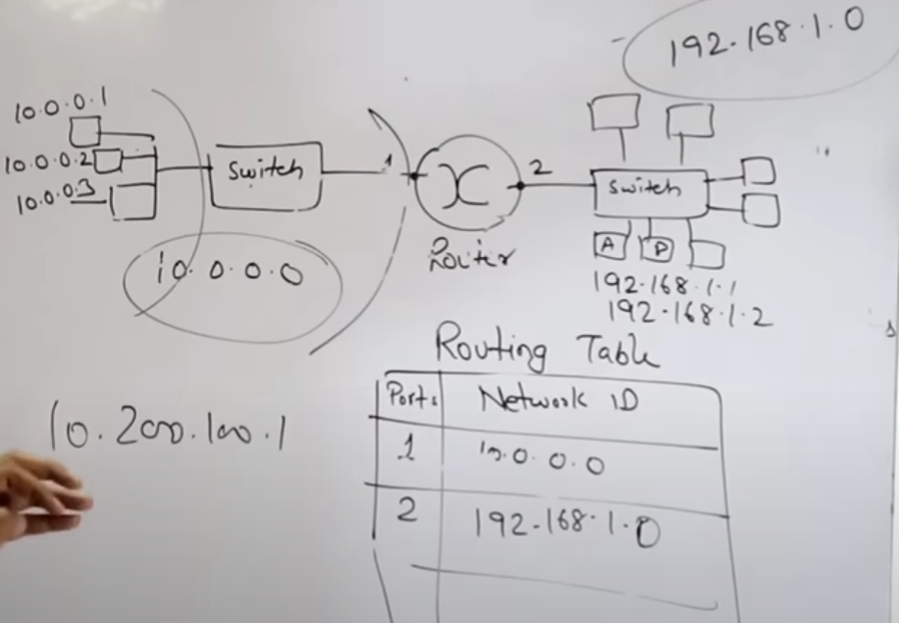
- Gateway :-
- Gateway is an entry/exit point of network. Sometimes it is implemented at switch.

